#### SEZNAM RAZSTAVLJALCEV POROTOROŽ 2016

|  |  |  |
| --- | --- | --- |
| **Št. razstav.**  **prostora** | **FIRMA** | **DRŽAVA** |
| 1S | EXOTERM-IT D.O.O. | SI |
| 2S | ELKEM AS | N |
| 3AR | FERROČRTALIČ D.O.O. | SI |
| 3BR | GRIMAS LTD. | H |
| 4AR | DIAMANT METALLPLASTIC GMBH | D |
| 4BR | LABENA D.O.O. | SI |
| 5R | CHEMETS D.O.O. | SI |
| 6R | STEM D.O.O. | SI |
| 7R | KOOZ D.O.O. | SI |
| 8AR | ROTO PAVLINJEK D.O.O. | SI |
| 8BR | UNIPLAST INŽENIRING D.O.O. | SI |
| 9AR | LABSYS D.O.O. | SI |
| 9BR | W ABRASIVES, ABRASIV MUTA D.O.O. | SI |
| 9S | AVTO G D.O.O. | SI |
| 10S | SWATYCOMET D.O.O. | SI |
| 11S | MESSER SLOVENIJA D.O.O. | SI |
| 12S | HAGI GMBH | A |
| 12S | STRIKOWESTOFEN GMBH | D |
| 13S | PSR D.O.O. | SI |
| 14R | TOPOMATIKA D.O.O. | CRO |
| 15R | TCT TESIC GMBH | D |
| 16S | ANALYSIS D.O.O. | SRB |
| 17S | OSKAR FRECH GmbH + Co. KG | D |
| 18S | CALDERYS DEUTSCHLAND GmbH | D |
| 19S | FONDAREX SA | CH |
| 20R | INDUCTOTHERM EUROPE LTD. | UK |
| 21R | BL-METAL, BOGDAN LOVŠIN S.P. | SI |
| 22S | SIAPRO D.O.O. | SI |
| 23S | GARANT-FILTER GMBH | D |
| 24S | LIVING D.O.O. | SI |
| 25S | TALUM SERVIS IN INŽENIRING D.O.O. | SI |
| 26S | TC LIVARSTVO / MECAS ESI S.R.O. | SI/CZ |
| 26AR | NARAVOSLOVNOTEHNIČNA FAKULTETA | SI |
| 26BR | IRT3000 | SI |
| 27R | TROKUT TEST D.O.O | SI |
| 28R | FERRUS GROUP SP. Z O.O. SP.K | PL |
| 29AR | FEAL-INŽENIRING D.O.O. | SI |
| 29BR | PRIMAKEM D.O.O. | SI |
| 30R | INSTRUMENTALIA D.O.O. | SI |
| 31R | MAZZON S.P.A. | I |
| 32R | INSERTEC ITALIA S.R.L. | I |
| 33R | FAPROSID S.R.L. | I |
| 34R | BELLOI&ROMAGNOLI S.R.L. | I |
| 35R | EKW KREMEN D.O.O. | SI |
| 36S | TERMIT D.D. | SI |
| 37S | HÜTTENES-ALBERTUS GmbH | D |
| 38S | RWP GmbH | D |
| S 0 | E3, ENERGETIKA, EKOLOGIJA, EKONOMIJA, D.O.O. | SI |

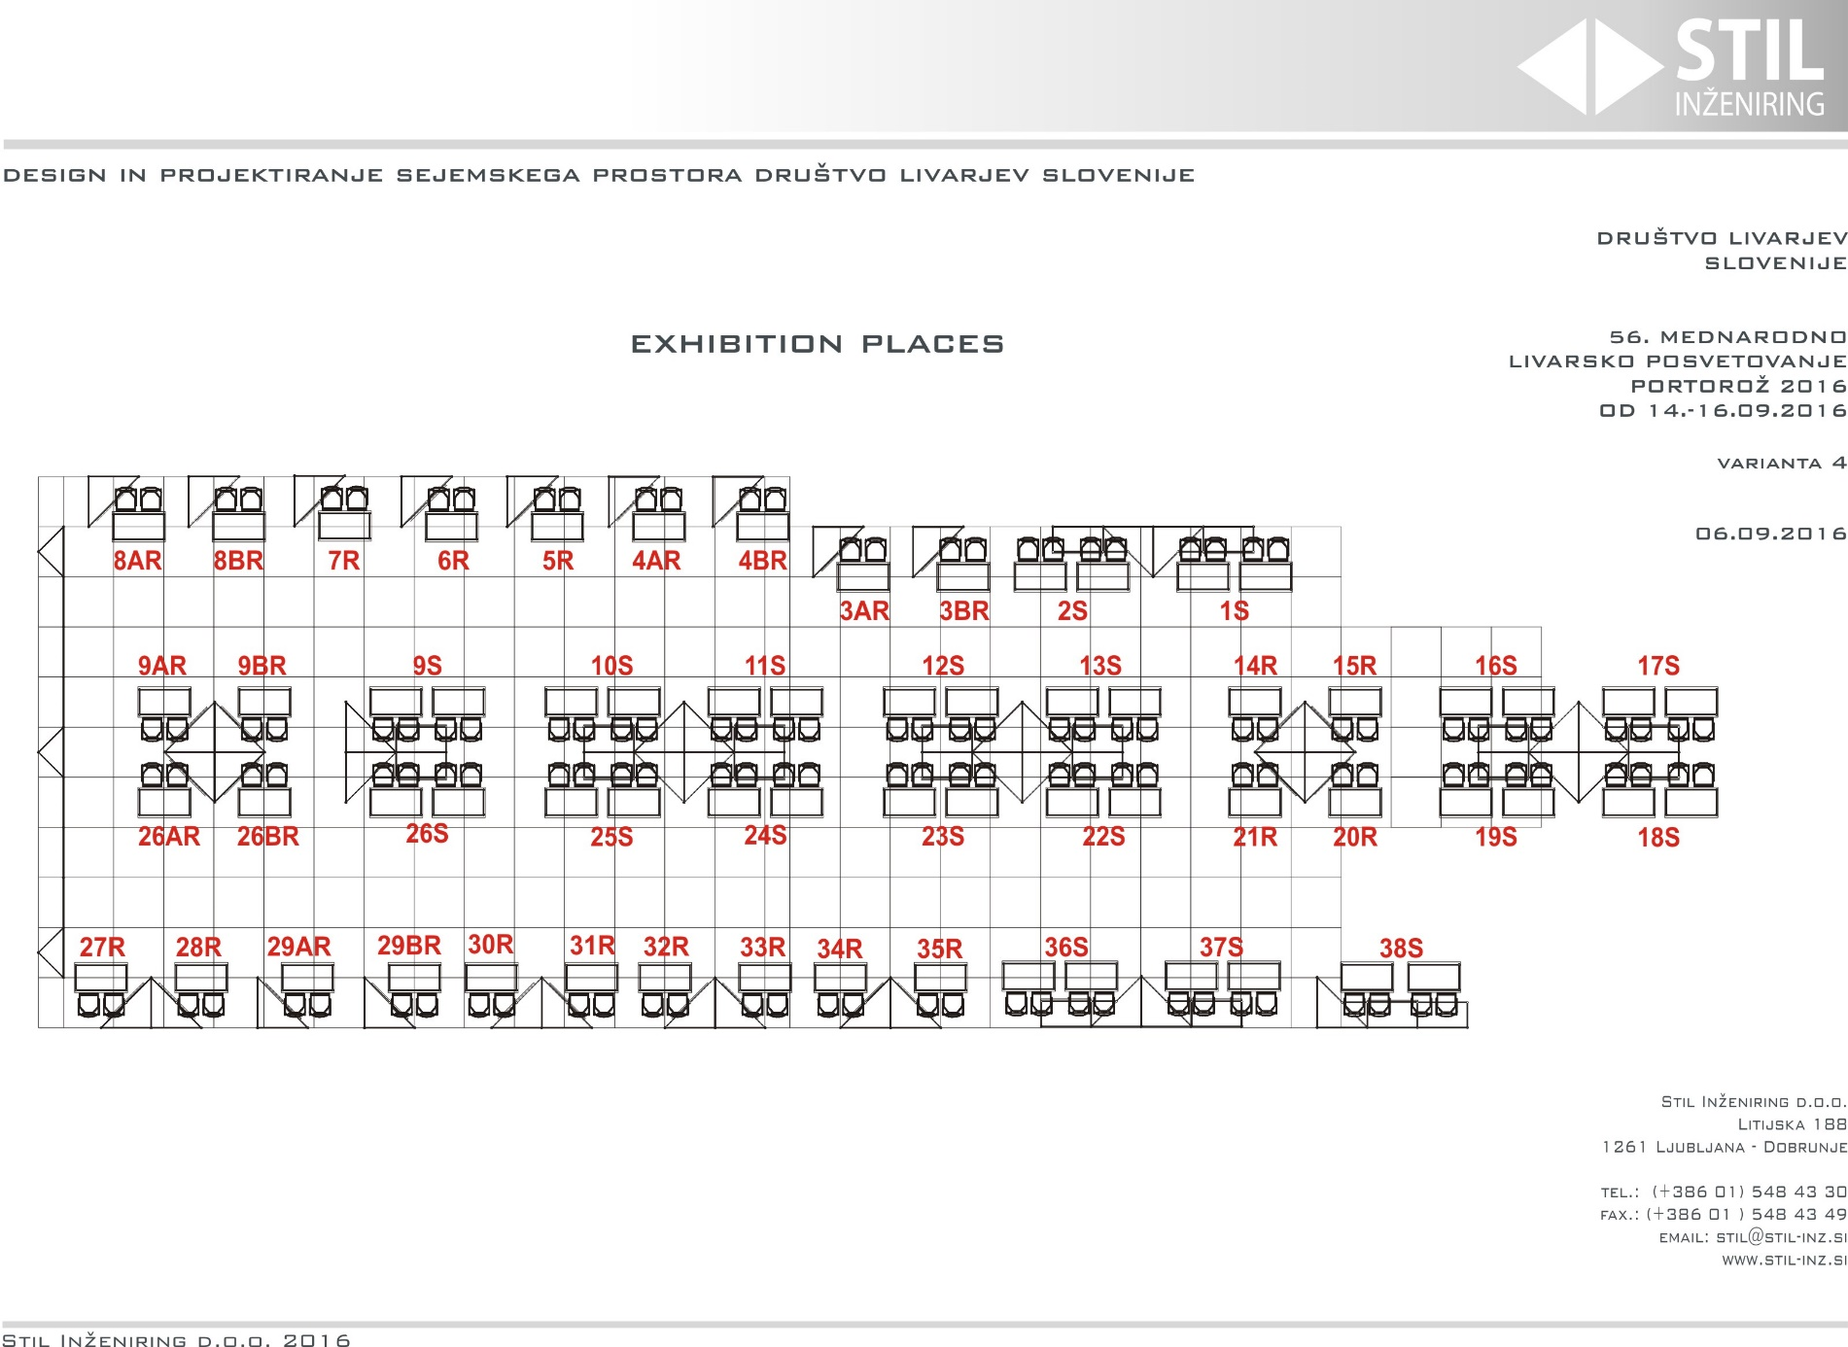

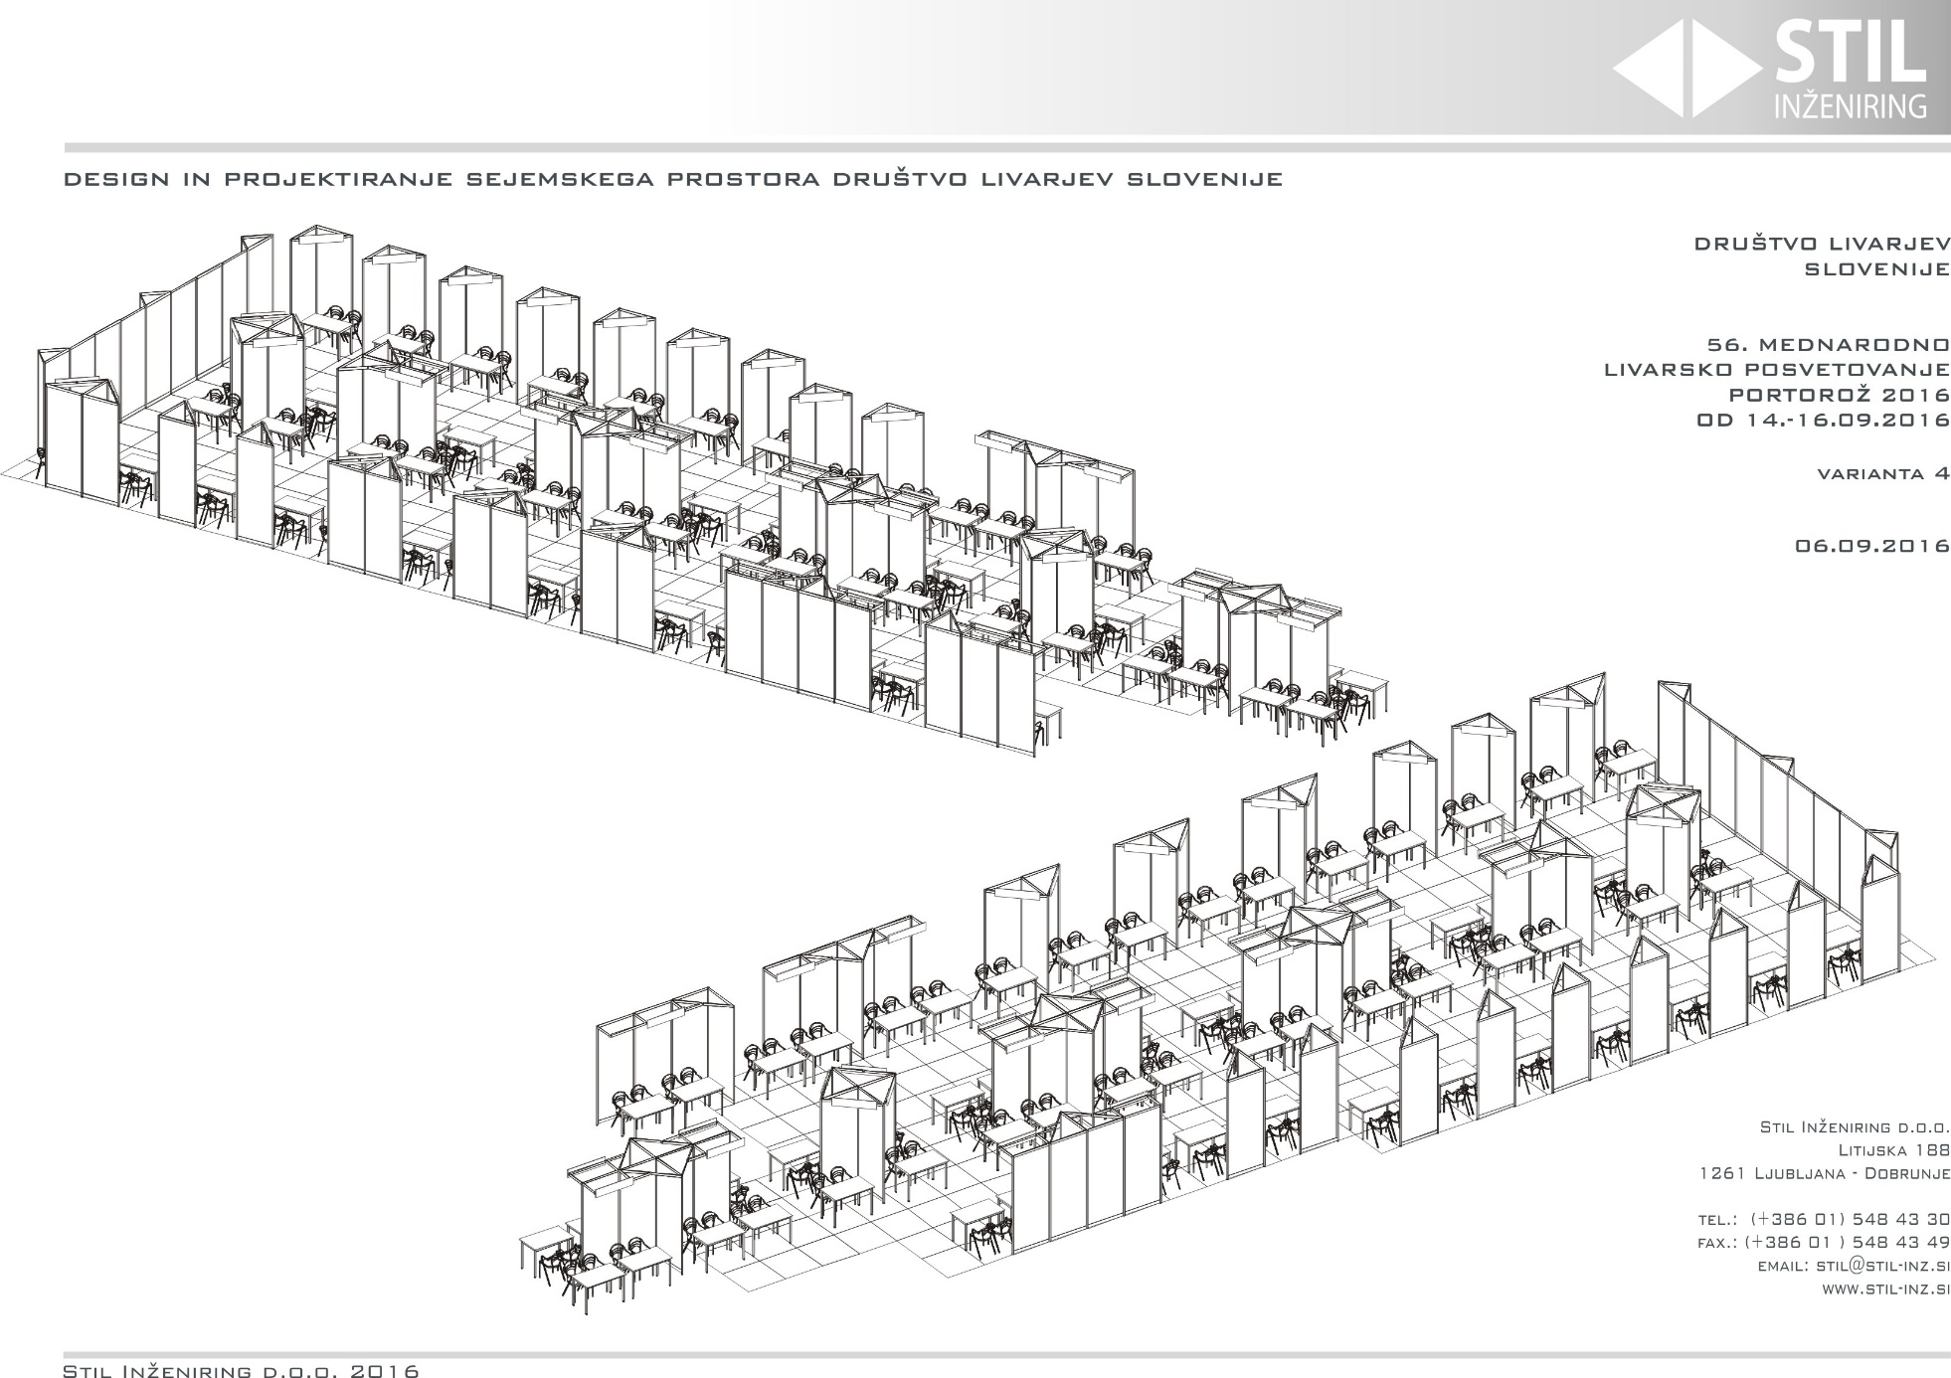

#### Kongresni center Hotel Slovenija: dvorana James Cook + Foyer

#### kongresni_center_tloris

