#### SEZNAM RAZSTAVLJALCEV POROTOROŽ 2015

|  |  |  |
| --- | --- | --- |
| **Št. razstav.**  **prostora** | **FIRMA** | **DRŽAVA** |
| 1S | EXOTERM-IT D.O.O. | SLO |
| 2S | ELKEM AS | N |
| 3S | SIAPRO D.O.O. | SLO |
| 4S | MESSER SLOVENIJA D.O.O. | SLO |
| 5R | CHEMETS D.O.O. | SLO |
| 6R | LABENA D.O.O. | SLO |
| 7R | KOOZ D.O.O. | SLO |
| 8AR | ROTO PAVLINJEK D.O.O. | SLO |
| 8BR | IB-CADDY D.O.O. | SLO |
| 9S | SAFOND-MARTINI S.R.L. | I |
| 10S | SWATYCOMET D.O.O. | SLO |
| 11S | STRIKOWESTOFEN GROUP | D |
| 12S | +HAGI+Ingenieurbüro | A |
| 13S | ELECTRONICS GmbH | D |
| 14R | MAHLE LETRIKA GROUP | SLO |
| 15R | TCT TESIC/OGICOM | D/SLO |
| 16S | ANALYSIS D.O.O. | SRB |
| 17S | OSKAR FRECH GmbH + Co. KG | D |
| 18S | CALDERYS DEUTSCHLAND GmbH | D |
| 19S | INDUCTOTHERM EUROPE | UK |
| 20R | PRIMAKEM D.O.O. | SLO |
| 21R | TOPOMATIKA D.O.O. | CRO |
| 22S | TALUM SERVIS IN INŽENIRING D.O.O. | SLO |
| 23S | FERROČRTALIČ D.O.O. | SLO |
| 24S | LIVING D.O.O. | SLO |
| 25S | GRIMAS Ltd. | H |
| 26S | MECAS ESI S.R.O./ TC LIVARSTVO | CH/SLO |
| 27R | NARAVOSLOVNOTEHNIČNA FAKULTETA | SLO |
| 28R | IRT3000 | SLO |
| 29AR | SISTEMSKA TEHNIKA D.O.O. | SLO |
| 29BR | FEAL- INŽENIRING D.O.O. | SLO |
| 30R | SES GROUP D.O.O. | SLO |
| 31R | FAPROSID S.R.L. | I |
| 32R | MAZZON S .P.A. | I |
| 33R | BELLOI&ROMAGNOLI S.R.L. | I |
| 34R | TDR LEGURE D.O.O. | SLO |
| 35R | EKW KREMEN D.O.O. | SLO |
| 36S | TERMIT D.D. | SLO |
| 37S | RWP GmbH | D |
| 38R | APR-Predstavništvo tujih sejmov | SLO |
| 39R | LOTRIČ MEROSLOVJE D.O.O. | SLO |

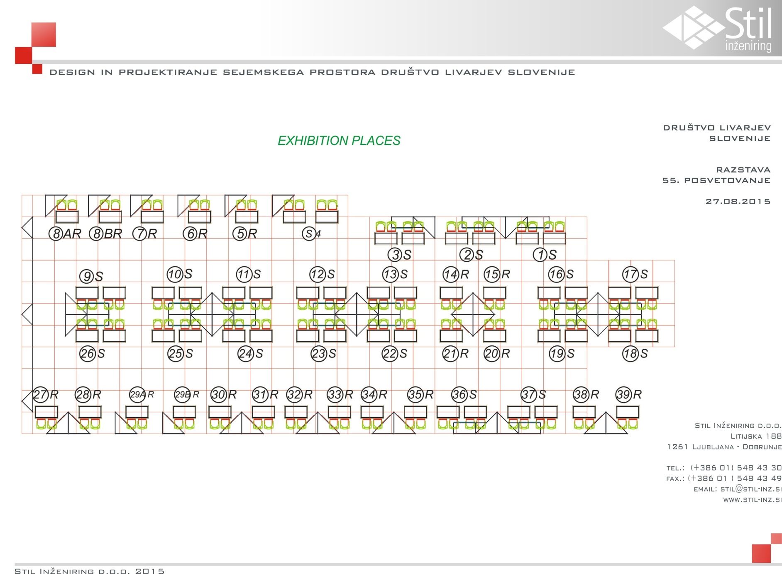

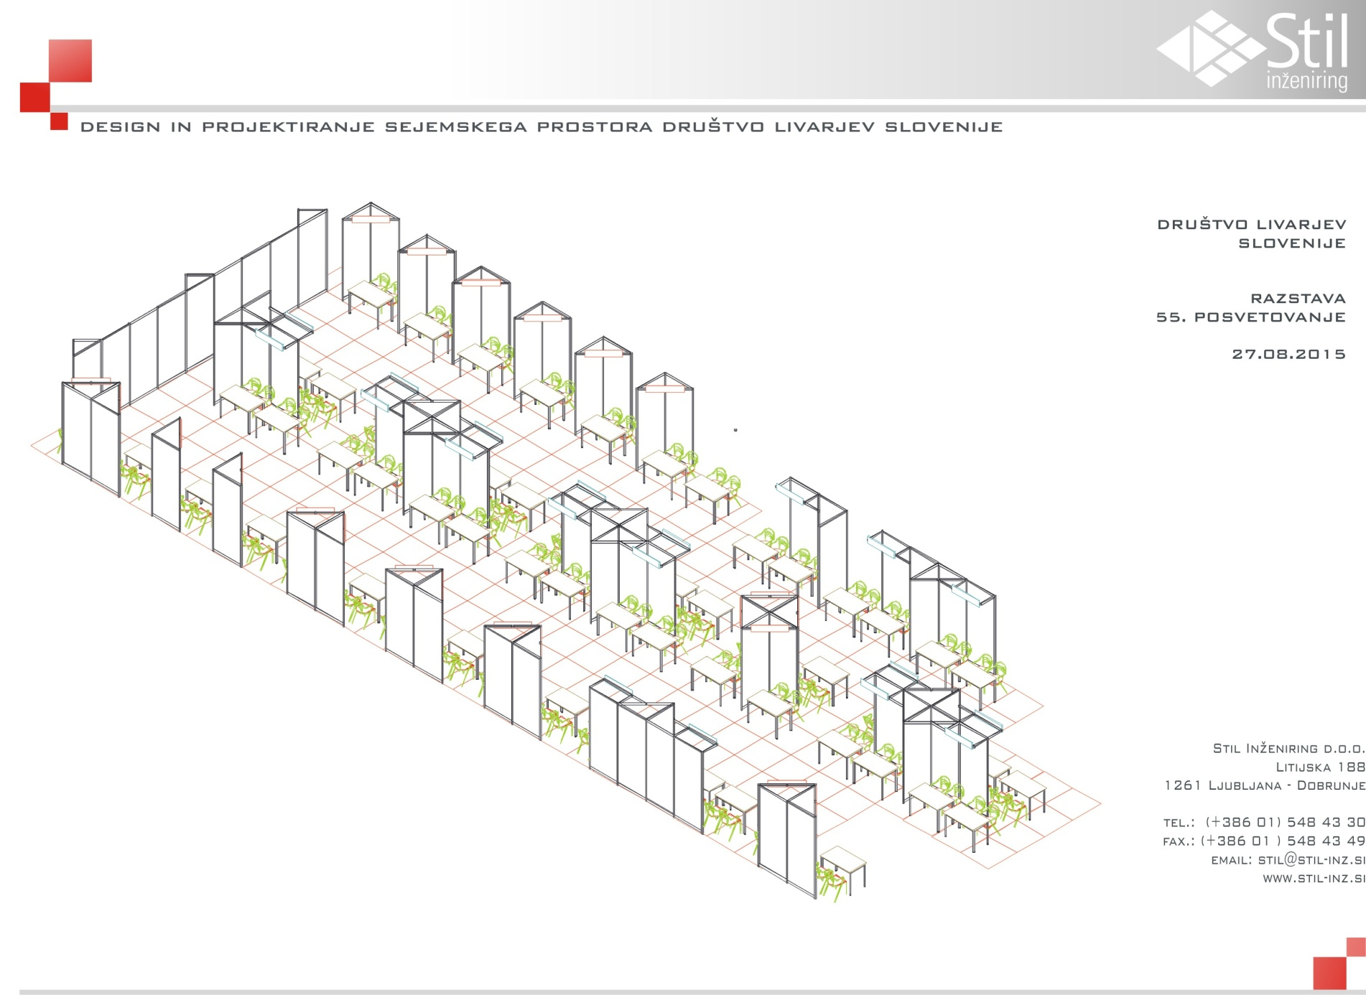

#### Kongresni center Hotel Slovenija: dvorana James Cook + Foyer

#### kongresni_center_tloris

