IME PRIIMEK⁽¹⁾, NAME SURNAME⁽²⁾, ⁽¹⁾Organizacija (KRATICA DRŽAVE), ⁽²⁾Affiliation (COUNTRY CODE),
Primer/Example: DOMEN NOVAK¹, JOHN WILSON², ¹University of Ljubljana (SI), ²University of Birmingham (UK)

NASLOV / TITLE

Povzetek / Abstract

Povzetek predavanja mora vsebovati od 1.600 do 3.300 znakov s presledki (kjer v število znakov niso vštete tudi navedbe avtorjev in naslov predavanja), na A4 formatu s pisavo Times New Roman, velikost 12pt. Povzetek mora vsebovati samo besedilo brez slik in tabel.
The length of the abstract is limited from min. 1.600 to max. 3.300 characters with spaces (Names of the authors and the title should not be included in the character count). The format is A4, Times New Roman font, size 12pt.

Ključne besede / Key words: Avtor določi 3-4 ključne besede, s katerimi natančno določi vsebino članka / The author must supply 3–4 keywords that describe the content of the article and are suitable for indexing and searching.

- Uvod / Introduction

Merske enote, enačbe / Symbols, equations (units of measurement)
Obvezna je raba merskih enot, ki jih določa Odredba o merskih enotah (Ur. L. RS št. 26/01), tj. enot mednarodnega sistema SI (SIST EN ISO 80000). Enačbe se označujejo ob desni strani besedila s tekočo številko v okroglih oklepajih.
Units of measurement must comply with the Law of Units of Measurement and Measures (Official Gazette of the Republic of Slovenia No. 26/01), i.e., international SI units (ISO 80000). Equations must be marked on the right-hand side of the text with numbers in round brackets.

Citiranje / Citation
Bibliografski viri so zbrani na koncu članka in so oštevilčeni po vrstnem redu, kakor se pojavijo v članku. Sklic na vir mora biti v tekstu označen v oglatem oklepaju [1].
The references must be collected at the end of the article, and numbered in the order of their appearance in the text. The reference must be marked in the text in the square brackets [1].

- Poglavja / Chapters
Označevanje slik v tekstu, kot je Slika 1. / Marking images in text, such as Figure 1.

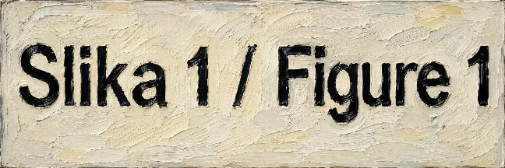
Slika 1: Kratek opis slike
Figure 1: Short figure description

Tabele morajo biti v besedilu jasno označene z arabskimi številkami. Vsaka tabela mora imeti naslov, ki omogoča razumevanje tabele brez sklicevanja na besedilo. Primer Tabela 1.
Tables must be clearly referred to in the text using Arabic numerals. Each table must have a title which makes the general meaning understandable without reference to the text. Example Table 1.

Tabela 1: Naslov tabele
Table 1: Table title

- Razprava in zaključki / Summary and conclusions
Knjige, periodične publikacije, deli knjig, članki v periodičnih publikacijah, patenti, elektronske monografije, članki in drugi prispevki v elektronski obliki morajo biti citirani kot kažejo primeri v referencah.
In the list of references, monographs, articles in journals, journals, contributions to conference proceedings, patent documents, electronic monographs, articles and other electronic documents must be cited in accordance with the examples in reference.

- Reference / Reference
Monografija / Books
[1] H. Ibach, H. Luth, Solid State physics, 2nd ed., Springer, Berlin 1991, 245
Članki v periodičnih publikacijah / Articles in periodicals
[2] T. Mauder, J. Stetina, Improvement of the casting of special steel with a wide solid liquid interface, Mater. Tehnol., 50 (2016) 1, 3–6, doi:10.17222/mit.2014.122
Prispevki v knjigah povzetkov konferenc in simpozijev / Contributions in books of conference and symposium abstracts
[3] I. Rak, M. Kocak, V. Gliha, N. Gubeljak: Fracture behaviour of over-matched high strength steel welds containing soft root layers, Proc. of the 2nd Inter. Symp. on Mis-Matching of Interfaces and Welds, Reinsford, 1997, 627–641
Prispevki v elektronski obliki dostopno na spletu / Contributions in electronic form available online
[4] LM Solutions: H13 Material Data Sheet: https://www.slm-solutions.com/fileadmin/Content/Powder/MDS/nw/MDS_H13_2023-06_EN.pdf (26.8.2024)

