#### SEZNAM RAZSTAVLJALCEV POROTOROŽ 2017

|  |  |  |
| --- | --- | --- |
| **Št. razstav.**  **prostora** | **FIRMA** | **DRŽAVA** |
| 1S | LABENA d.o.o. | SI |
| 2S | ANALYSIS d.o.o. | SRB |
| 3S | EXOTERM-IT d.o.o. | SI |
| 4S | ELKEM AS | N |
| 5R | MAHLE LETRIKA GROUP | SI |
| 6S | STEM D.O.O. | SI |
| 7R | BL-METAL, BOGDAN LOVŠIN s.p. | SI |
| 9S | SIAPRO d.o.o. | SI |
| 11R | CHEMETS d.o.o. | SI |
| 12R | FEAL-INŽENIRING d.o.o. | SI |
| 13R | KOOZ d.o.o. | SI |
| 14R | PRIMAKEM d.o.o. | SI |
| 15R | STERR & EDER INDUSTRIESERVICE GmbH | D |
| 16R |  |  |
| 17R | TROKUT TEST d.o.o. | SI |
| 18R | CARL ZEISS d.o.o. | SI |
| 19S | LABTIM d.o.o | SI |
| 20S | NÜRNBERGMESSE GmbH | D |
| 21S | AED AUTOMATION GmbH | D |
| 22S | HAGI GmbH | A |
| 23S | STRIKOWESTOFEN GmbH | D |
| 24S | WOLLIN GmbH | D |
| 26S | FERROČRTALIČ d.o.o. | SI |
| 27S | OSKAR FRECH GmbH + Co. KG | D |
| 28S | OMEGA FOUNDRY MACHINERY ltd | UK |
| 29R | INSTRO d.o.o. | SI |
| 30R | IB-CADDY d.o.o. | SI |
| 31R | IDEF d.o.o. | CRO |
| 32R | IRT3000 | SI |
| 33S | INDUCTOTHERM EUROPE ltd. | UK |
| 34S | CALDERYS DEUTSCHLAND GmbH | D |
| 35S | GARANT-FILTER GmbH | D |
| 36S | KS KNEISSL & SENN TECHNOLOGIE GmbH | A |
| 38S | LIVING d.o.o. | SI |
| 39S | MESSER SLOVENIJA d.o.o. | SI |
| 40S | SWATYCOMET d.o.o. | SI |
| 41S | INSERTEC ITALIA s.r.l. | I |
| 42S | OLMA d.o.o. | SI |
| 43R | LABSYS d.o.o. | SI |
| 44R | SIJ GROUP - SILABS | SI |
| 45R | OFFICINE MECCANICHE BELLOI&ROMAGNOLI s.r.l. | I |
| 46R | BOSSELO HIGH TECHNOLOGY srl | I |
| 47R | ITALPRESSE INDUSTRIE srl | I |
| 48R | FONDAREX SA | CH |
| 49R | AVL LIST GmbH | A |
| 50R | HEINRICH WAGNER SINTO MASCHINENFABRIK GmbH | D |
| 51R | TCT TESIC GmbH | D |
| 52R | EKW KREMEN d.o.o. | SI |
| 53R | TOPOMATIKA d.o.o. | CRO |
| 54R | UNIVERZA V LJUBLJANI, NARAVOSLOVNOTEHNIČNA FAKULTETA | SI |
| 55S | TC LIVARSTVO d.o.o. / MECAS ESI s.r.o. | SI/CZ |
| 56S | TALUM d.d. | SI |
| 57S | Q TECHNA d.o.o. | SI |
| 58S | RWP GmbH | D |

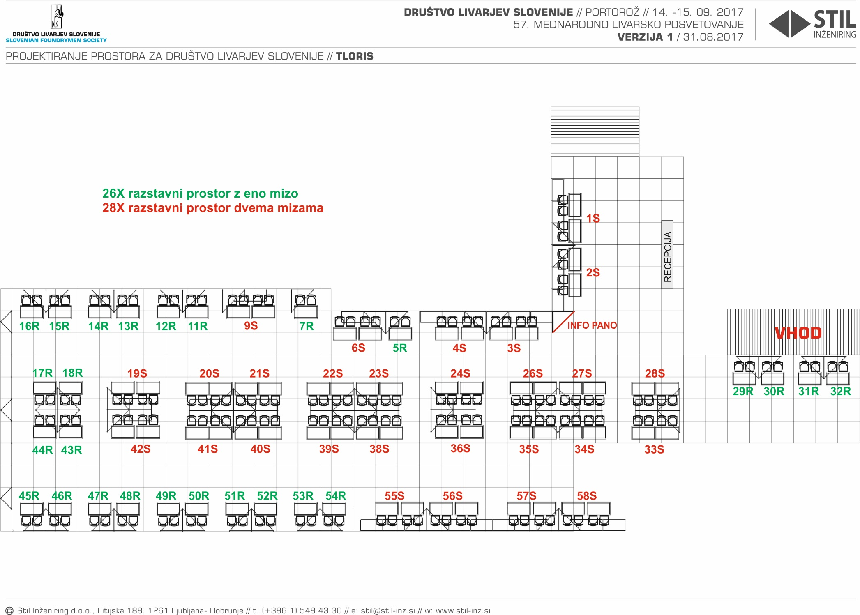

#### Kongresni center Hotel Slovenija: dvorana James Cook + Foyer

#### kongresni_center_tloris

